**Task 3.**

**Context Diagram**

·         shows external entities and interactions

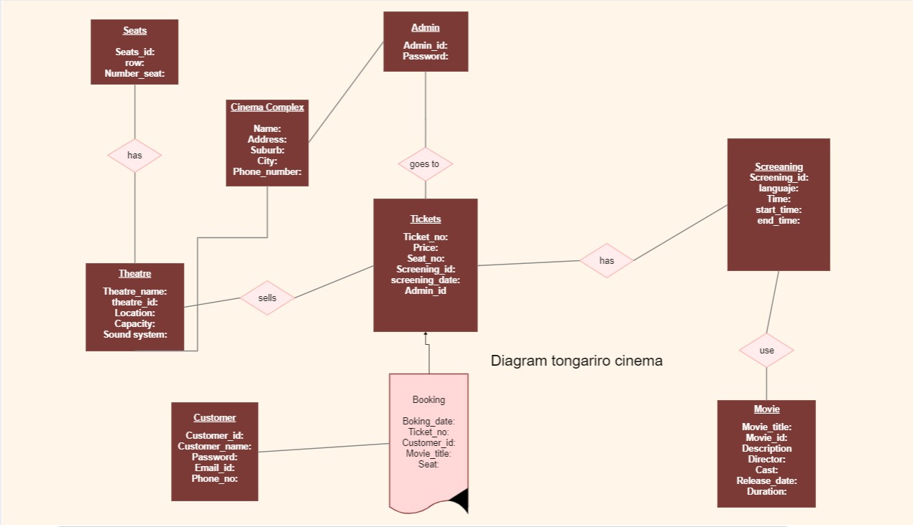

The entity of the movie ticket ordering system is represented by this ER diagram. The main components of this ER diagram for movie ticket ordering are the data items and relationships. An online ticket ordering system's entity-relationship diagram shows database tables and relationships for things like movies, customers, theatres, and screens. The primary components of the online system for purchasing movie tickets are the movie ticket website, the customer, the film, the booking, the film performance, the theatre, the screen, and so forth. A primary key and a unique key are both assigned to every entity.

In this case we having add the food elements as the coffee shop is a lease by a catering company.

**Task 4, 5.**

**Activity sequence diagram** ·

* uses correct notation (BPMN)
* describes one key business process

This example is about cinema business process and the interaction with the costumer. Because we want to model the interaction between the customer and the movie screening and how is made the process of business.

We start with our main key for our business process ‘the customer’ who get the first quarter of our diagram, the customer is looking for something simple just entertainment, our management should have ready the weekly screening for the theatre and the customer to choose the movie, after they chose the film they can choose the seats, and finally pay. Later it pass for a process of validation. For the end we have our cinema crew who they are on the day of the screening, putting movie, cutting ticket and directing people to their seats as ones that clean the cinema as well, that help for the customer had a great time in there.